Open letter to local Rockland papers and to our sponsors.

RCN-NCR 2013: Thank you to our supporters

Rockland's third annual RCN-NCR (Région de la Capitale Nationale – National Capital Region) Rubik's cube competition took place at the Optimist hall on Saturday May 18. 50 people took place in the main event, solving the 3x3x3 as fast as possible. Based on that statistic, our competition is one of the largest in the country (65 people competed in the Waterloo Open 2012; 115 at Toronto Open Winter 2013, and 49 – one less than us – at the Montreal 2013 competition).

We would like to thank our supporters and our sponsors. A special Thank You to our GOLD partners:
- the Exprime-toi program, from Ontario's Ministry of the Education
- Desjardins, Caisse populaire Trillium
They helped us with our 2012-2013 season operating costs, buy some equipment and allowed us to give cubing demonstrations in the community and at the Museum of science and technology in Ottawa.

We would also thank our SILVER sponsor:

- Rockland's Knights of Columbus, Council 6198

Finally, our BRONZE sponsors:

- Bélanger Chrysler Dodge Jeep Ram, Rockland
- Jean Coutu pharmacy, Rockland
- Tim Hortons, Rockland
- Canadian Tire Rockland
- Dre D. Frigault Optometrist, Rockland
- Rubik Promotions, Victoria

Generous donations from those sponsors allowed us to provide prizes for each of the 8 official events we held, as well as a few door prizes. Rubik Promotions gave a trophy to the winner of the 3x3x3 event, and gold/silver/bronze medals to winners of each of the events.

Canadian Cubing (canadiancubing.com) oversaw the day, allowing us to qualify as one of the WCA (World Cube Association; worldcubeassociation.org) official competitions.

A Thank You to the école secondaire catholique L'Escale, home of Le Club de Cube, where this three-year long journey has started, and home of the RCN-NCR series of competitions. De La Salle High School in Ottawa also has a cubing club, and some of their members came and competed.

Many of the best Canadian cubers were at the Rockland competition. In fact, three significant national records were broken:
- 3x3x3 one handed (average); Canadian record, by Antoine Cantin (Rockland); 15.23 seconds
- 4x4x4 (“single”); Canadian record, by Louis Cormier (Rockland); 35.08 seconds
- 3x3x3; Malaysian national record, by Jonathan Tan Wei Xiat (Malaysia); 9.77 seconds

Two Rockland competitiors stood out from the others, each getting 6 medals out of a possibility of 8:
- Antoine Cantin: 3rd, blindfolded (1:22.33), 2nd in Megaminx (1:12.94), 1st with his feet (47.14), 3rd in 4x4x4 (46.76), 3rd in 2x2x2 (3.16) et 1st in 3x3x3 one handed (18.97)
- Louis Cormier: 1st in Megaminx (56.47), 2nd with this feet (49.94), 1st in 4x4x4 (40.39), 2nd in Pyraminx (6.14), 2nd in 2x2x2 (3.10) et 2nd in 3x3x3 (10.28)
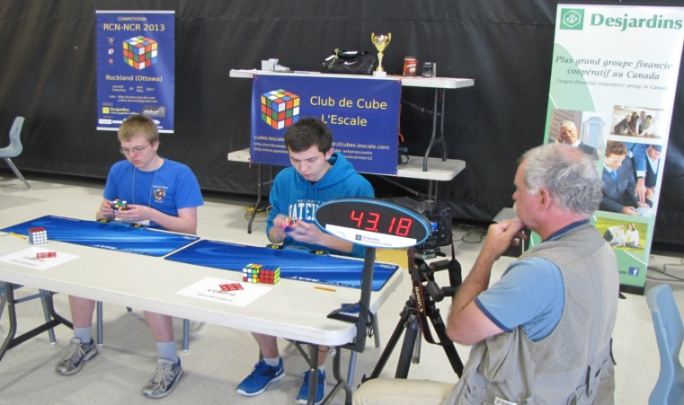 Antoine Cantin and Louis Cormier, with Chris Mikula from the Ottawa Citizen

Detailed results are available on the World Cube Association Web site. A link ito that site is also on the local Club de Cube L'Escale site (http://cubes.lescale.com/).

The next steps for our local cubers are the Canadian Open 2013 competition in Toronto, on July 6-7, followed by the Rubik's World Championship 2013, in Las Vegas on July 26-28, 2013.

Thank you to our supporters and our season's sponsors,

Claude Cantin
for Le Club de Cube L'Escale
cubes.lescale@gmail.com

